Netflix Project (shift+enter) – new line in DAX, # - shortcut key for hash is -alt+35 and shortcut key of double inverted comma is -alt+0147/0148

We have Genre and Type in one columns in report view and we want to have them in a dedicated one two table column :-

We will group them in one column:-

1.Listing Type =

SWITCH(

    TRUE(),

    Listings[Type] IN{"movie","tvMovie"},"Movie",

     Listings[Type] IN{"tvEpisode","tvMiniSeries","tvSeries","tvShort","tvSpecial"},"Television"

)

2.Now we are going to take first part of Genre

Genre =

LEFT(

    Listings[Genres],

    SEARCH(

        ",",

        Listings[Genres],

        ,

        LEN(Listings[Genres])+1

    )-1

)

*Taking left part or starting part look for comma and then take it.

3. we are now going to put rating in a group – CLICK ON RATING and then create a new Column.

Rating Group =

SWITCH(

    TRUE(),

Listings[Rating] >= 0 && Listings[Rating] <1, 0,

Listings[Rating] >= 1 && Listings[Rating] <2, 1,

Listings[Rating] >= 2 && Listings[Rating] <3, 2,

Listings[Rating] >= 3 && Listings[Rating] <4, 3,

Listings[Rating] >= 4 && Listings[Rating] <5, 4,

Listings[Rating] >= 5 && Listings[Rating] <6, 5,

Listings[Rating] >= 6 && Listings[Rating] <7, 6,

Listings[Rating] >= 7 && Listings[Rating] <8, 7,

Listings[Rating] >= 8 && Listings[Rating] <9, 8,

Listings[Rating] >= 9 && Listings[Rating] <10, 9)

**SUM -VOTES**

1.# Votes = SUM(Listings[Votes])

2.# Titles = DISTINCTCOUNT(Listings[ID])

3.AVG Rating = AVERAGE(Listings[Rating])

**1st Visual**

Funnel Chart - Category -Rating Group, Values -Titles

Made new table –

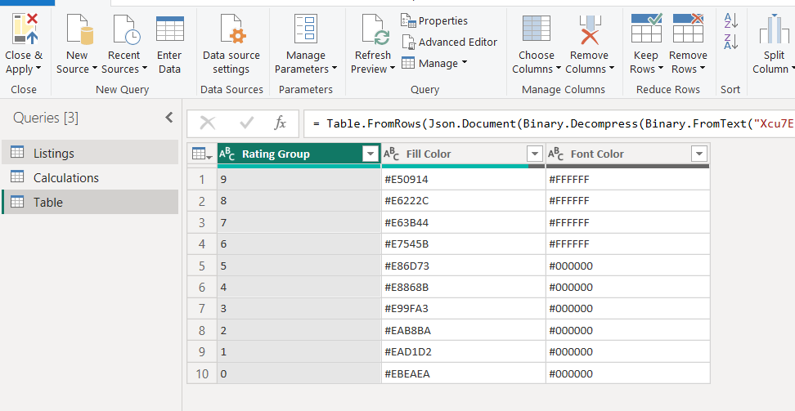

tvEpisode","tvMiniSeries","tvSeries","tvShort","tvSpecial

movie","tvMovie